Mahi Kāinga o Te Whaanau PipiPaopao Ruma 16
Whakaharatau ki te whakatangi i ngaa oro puare e rima, me ngaa oro taarua. (practice sounding the vowels and double vowels.)  a e i o u  aa ae ai ao au  ea ee ei eo eu  ia ie ii io iu  oa oe oi oo ou  ua ue ui uo uu  a - ‘a’ as in ‘ago’  e - ‘e’ as in ‘egg’  i - ‘i’ as in ‘ink’  o - ‘o’ as in ‘aw’ as in hawk  u - ‘u’ as in ‘flu’ | He aha tō mōhio mō te wai?  What do you know about water?  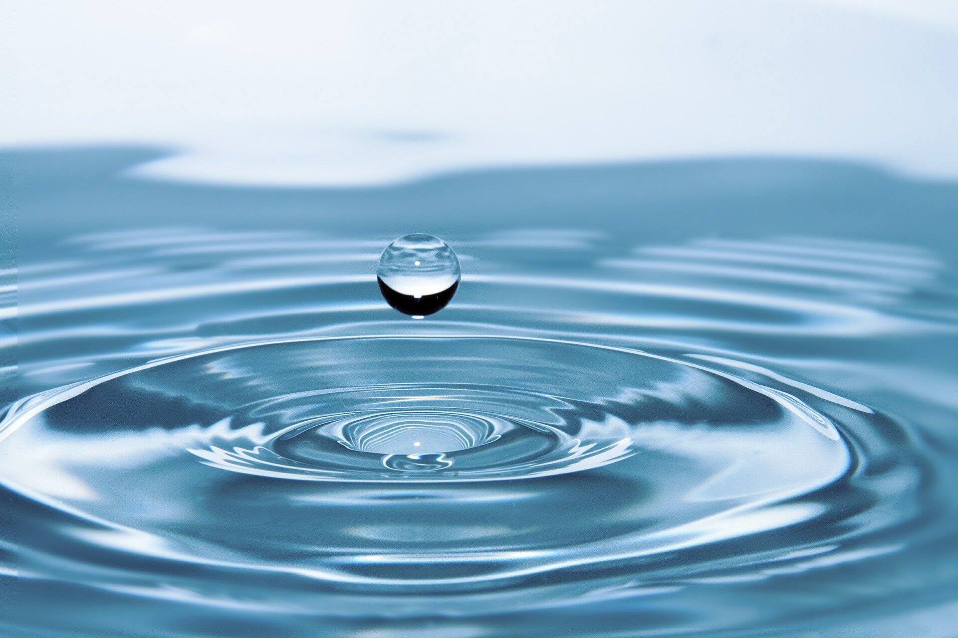  Tapahia kia rua ngaa whakaahua rereke e ahu mai ana he wai ki a tatou.  Cut out two different pictures of where we get water from. | Ka kite koe i te tauira o tēnei pikitia?  Can you see the pattern in this picture?  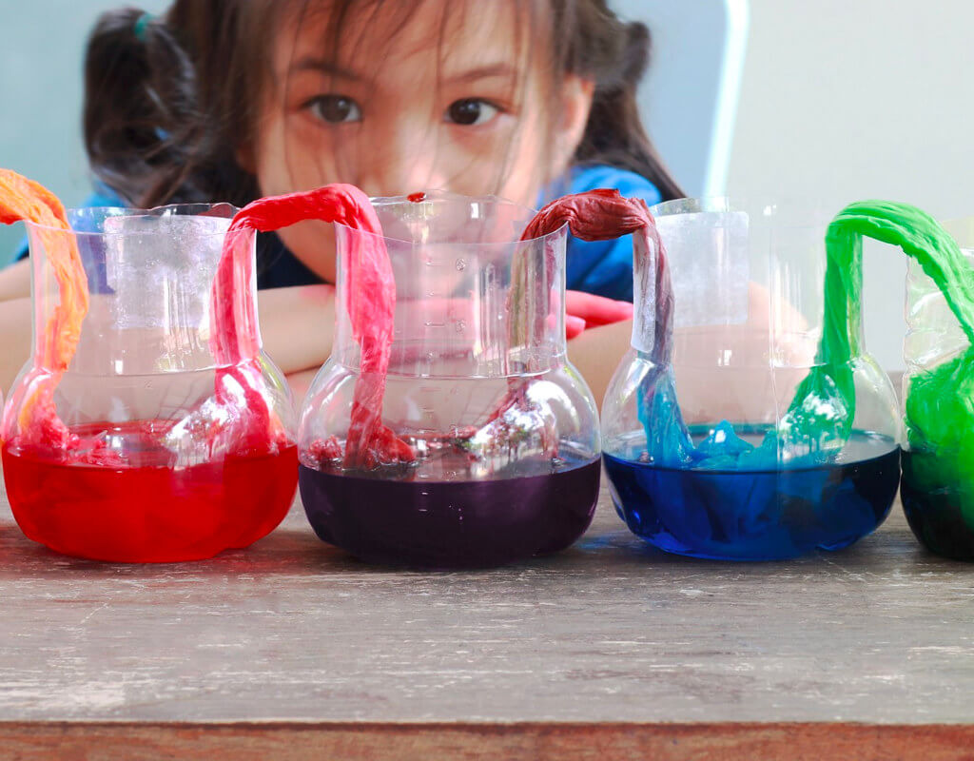  whero waiporoporo kikorangi kakariki  E rua ou tae, he tae kei ia poraka kia rite ai to tauira. You have two colors, color in each block to make your pattern.
Tatau 1 ki te 10 (count 1 to 10)  1 2 3 4 5 6 7 8 9 10  Ka hoki mai i te 10 ki te 1 (and back 10 to 1)  10 9 8 7 6 5 4 3 2 1  Whakaharatau ia rā, kia maia rā anō koe. (practice every day until you are confident.) | Kitea ēnei kupu? Find these words?  Ārahi kei tatari whaka  he kurī te whiti  heke noho tēnei  Ā r a h i h a a h w  w h a k a e k u r ī  w h i t i t ē n e i  n o h o r w k i t u  t a t a r i o m e n | Panuihia ‘He Kurī Ārahi’  He Kurī Ārahi  He kurī ārahi.  He kurī ārahi tēnei.  Kei te hīkoi.  Kei te noho.  Kei te heke.  Kei te ārahi.  Kei te tatari.  Kei te whakawhiti.  He kurī ārahi
Hangaia tetahi hurihanga wai ahu 3
Design/Create your very own 3D water cycle explaining how it works. .
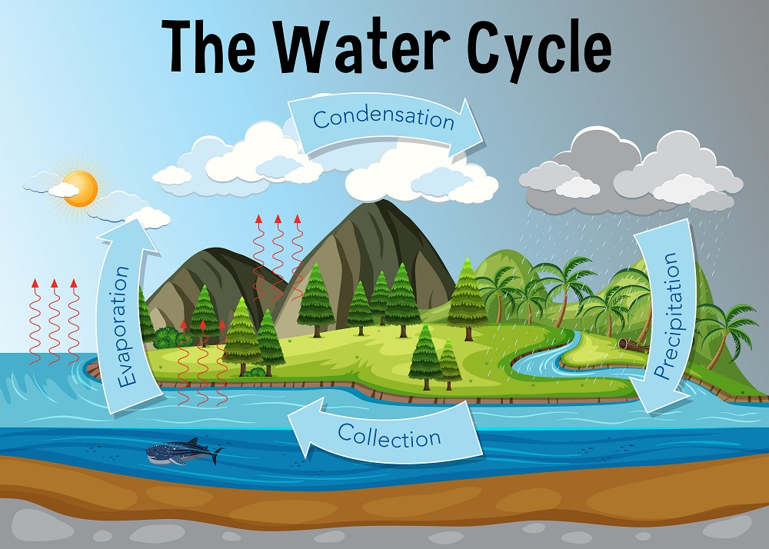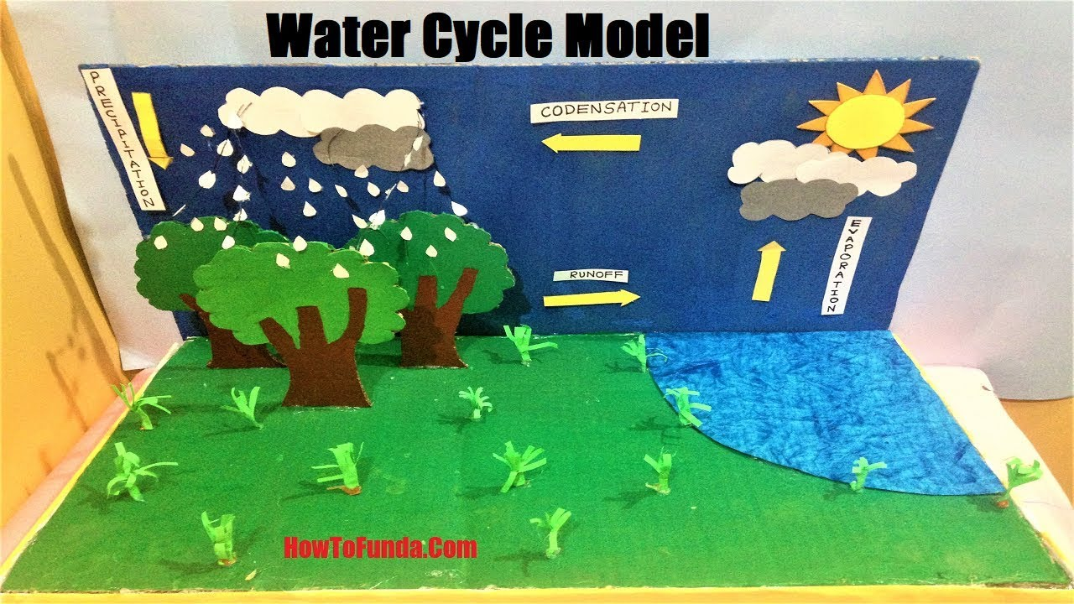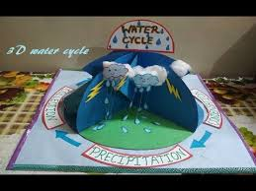

PAEARU/CRITERIA:
- Me awhina ia tāngata o tō whānau i a koe ki te hanga i tō ahu 3.
All whānau must contribute somehow in some way to your 3D.

- Kei a koe te tikanga mō ngā momo rauemi ka whakamahi.
It’s up to you what materials you would like to use.

- Patopato he kōrero/ whakamārama i ngaa waahanga.
Type/explain the parts of the water cycle.

4. Kia ātaahua kia pīrakorako mai ngā tae( Make it bright and colourful)

6. Kia kaha, kia maia, kia manawanui.
Have fun and think outside the box.

WHAKAHOKIA MAI/DUE: TBC Week 10

Whakautu i enei patai e pā ana ki te huringa o te wai?

- What is the water cycle?
- Where does rain come from?
- Where does rainwater go?
- What has the weather got to do with the water cycle?
- How do our plants interact with the water cycle?
- Where did water come from?
- Does our use of water have an affect on the water cycle?
- How much water is there?
- Does water ever disappear completely?
- Is water always moving?

