Room: 18 Home Learning Choice Board Wk5 Tm3 2021
Kia Ora Whanau, this learning choice board is for your child to use while at home.
On this board there are different activities your child can choose to do either individually or as a family.
MAKE YOUR DIGRAPHS/ BLENDS GAME  Arrange some chairs back to back and place a Digraph/ blend card on each chair. When the music begins ask your players to walk around the chairs in a circle. When the music stops, encourage your players to pick up a digraph/ blend card, say it out aloud and a word that it would be used in, then sit in chair. The last player to sit down is out.  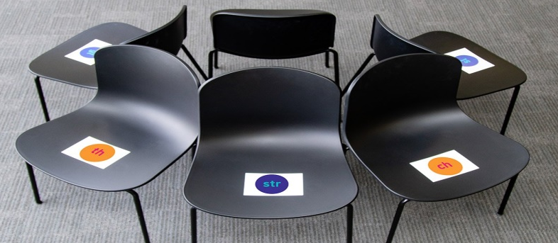  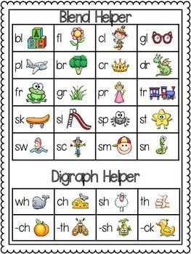 | HELP WITH PREPARING BREAKFAST  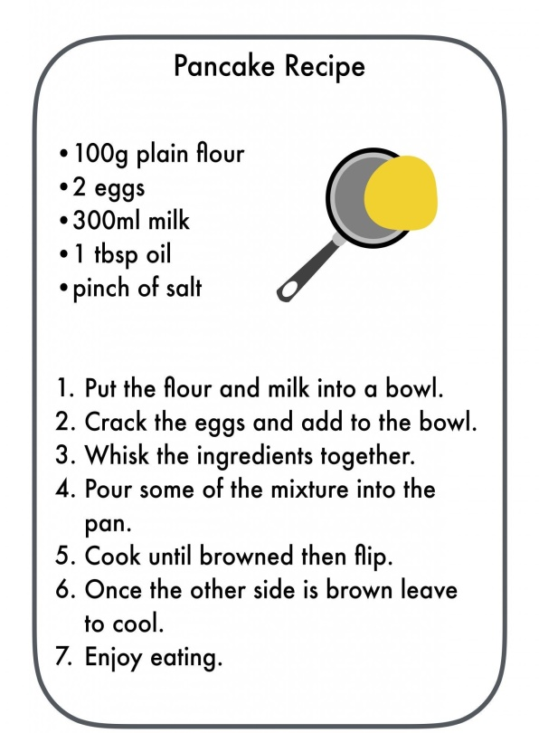
INDOOR SCAVENGER HUNT  - Find a fork  - Find something that is Red  - Find a box  - Find three things that are hard  - Find a sticker  - Find 2 socks that match  - Find a pair of glasses  - Find an envelope | HELP WITH GARDENING, WHAT CAN YOU SEE?  Remembering from our Plant growth of a Mung Bean, try and grow a avocado  https://www.youtube.com/watch?v=gUMnja2Cg6s  Write a diary of what has happened over a week and take photo’s
Reading: Aroha’s way, written by Craig Phillips
https://www.youtube.com/watch?v=6irr_hGCRl0

- Click on the link to get the book of the week, turn the volume down and pause the video so your child/ ren can read the book individually.
- We all get stressed and worried sometimes. To start the kōrero, talk about a couple of times you’ve been worried. Then ask:
- How do we know we’re worried? What does it feel like in our body?
- Sick, overwhelmed, sore tummy, headaches, sweaty hands or armpits, hard to talk, heart beating fast.
- What can we do to help worries go away?
- Talk to someone, do something to fix it or feel good. Take deep breaths.
- What shouldn’t we do? What makes it worse?
- Keeping it bottled up, pretending it will go away, thinking scary things, not telling anyone, or talking to people who also tend to worry.

Maths:
Patterns can grow or repeat depending on the rule. Recognising number patterns are an important part of feeling confident in maths. In this topic we will look at different number patterns.
Number patterns in tables can help us with problems like this.

Mia is making this sequence of shapes with matchsticks and wants to know how many she will need for 10 shapes.

Shape number | 1 | 2 | 3 | 4 | 5 | 10
Number of matchsticks | 3 | 6 | 9 | 12 | 15 | ?

To find out how many matchsticks are needed for 10 triangles, we don’t need to extend the table, we can just apply the function rule:
Number of matchsticks = Shape number × ?

Complete the table for each sequence of matchstick shapes and find the number of matchsticks needed for the 10th shape.

Shape number | 1 | 2 | 3 | 4 | 5 | 10
Number of matchsticks | 6 | ? | ? | ? | ? | ?

Shape number | 1 | 2 | 3 | 4 | 5 | 10
Number of matchsticks | 7 | ? | ? | ? | ? | ?

Descriptive Writing: He Tuhinga Whakaahua
Images speak for themselves and are very powerful.

Have your child/ren grab a photo that they are really fond of.
Part One – “What does he/she look like?”
What is going on in this photo?
Part two – ”What do you see that makes you say that?”
Facial expressions, height, built.
Part three – Add verbs, describe activities associated with the topic
What more can you find?

Have fun choosing from the choice board. Take care and stay safe – Whaea Stephanie

