 | Te Whānau Kererū noho mirumiru
Rāhina | Rātū | Rāpare | Rāpare | Rāmere
Series 3 Episode 2  Ko wai te ingoa o ngā kōtiro o te hōtaka NiuTube?  He aha te hononga ki waenga nui i ēnei kōtiro?  I haere rāua ki whea mō te haerenga?  He aha ngā mea i kitea e rāua ki runga i tēnei haerenga?  He aha tētahi o ngā ekenga i eke e ngā kōtiro?  He aha te ekenga i whakamataku i ngā kōtiro?  I hanga ngā kōtiro i te aha?  He ngā taputapu i whakamahia e rāua?  He aha ngā perehana i whakawhiwhia e rāua i te mutunga?  Homai kia 5 ngā kupu hou me ōna whakamāramatanga | Link: https://www.youtube.com/watch?v=wgLWdCrgR7w&list=PLy2ye79tWsUwk5jXI-gQp_GXCnRGvjwtu  He aha te taitara tapanga rānei?  What is the title?  Ko wai te kaituhi  Who wrote the book?  Ko wai te kaitā pikitia  Who created the pictures?  Ko wai ngā kiripuaki?  Who are the characters?  He aha te ngako o te pukapuka?  What is the main idea of the book?  he aha tō whārangi tino pai?  What is your favourite page?  Draw a picture of your favourite page.  Waihangahia he rotarota, he pao, he waiata, he haka rānei e pā ana ki tāu pukapuka.  Write a poem, a chant, a song, or a haka about your book you have read. | Utilising what we have at home measure the following using your fingers, hands, feet, footsteps, arm span and your body to measure the length and height of a:  - Door  - Table  - Fridge  - Car  - Stove  - Bedroom window  - Your front or back yard  - Driveway  - Garden  Select the appropriate measuring tools to match the item being measured e.g driveway footsteps, feet, arm span. Each item must be measured in 3 different ways using the options above. | Mātaki tētahi tūmahi whēako mā runga youtube a hāngai ana ki te wai.  whakamātauhia i taua tūmahi whēako.  Wiki tuawhitu ka tū koe ki mua i te akomanga ki te whakapuaki i tō tūmahi whēako.  Watch a science experiment about water  Test out the experiment.  Week 7 present your experiment to the class. 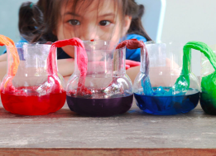 | DO: Download the amazing app - Kupu and use the camera on your phone to instantly translate objects around the home into Te Reo Māori.  Make reo signs and put them next to basic objects - use this time to try and use as many Māori words everyday as possible for everyday things
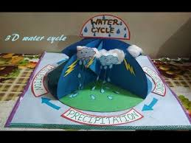
Hangaia tetahi hurihanga wai ahu 3

PAEARU/CRITERIA:
- Me awhina ia tāngata o tō whānau i a koe ki te hanga i tō ahu 3.
All whānau must contribute somehow in some way to your 3D.
- Kei a koe te tikanga mō ngā momo rauemi ka whakamahi.
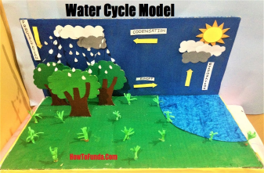
It’s up to you what materials you would like to use.

- Patopato he kōrero/ whakamārama i ngaa waahanga.
Type/explain the parts of the water cycle.

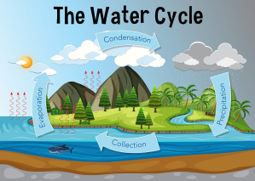
4. Kia ātaahua kia pīrakorako mai ngā tae( Make it bright and colourful)

