Mahi Kāinga o Te Whānau Kererū mō tēnei kaupapa te wai.
Tāngia tētahi hurihanga wai me ōna whakamāramatanga .  Draw a picture of a water cycle explaining how it works.  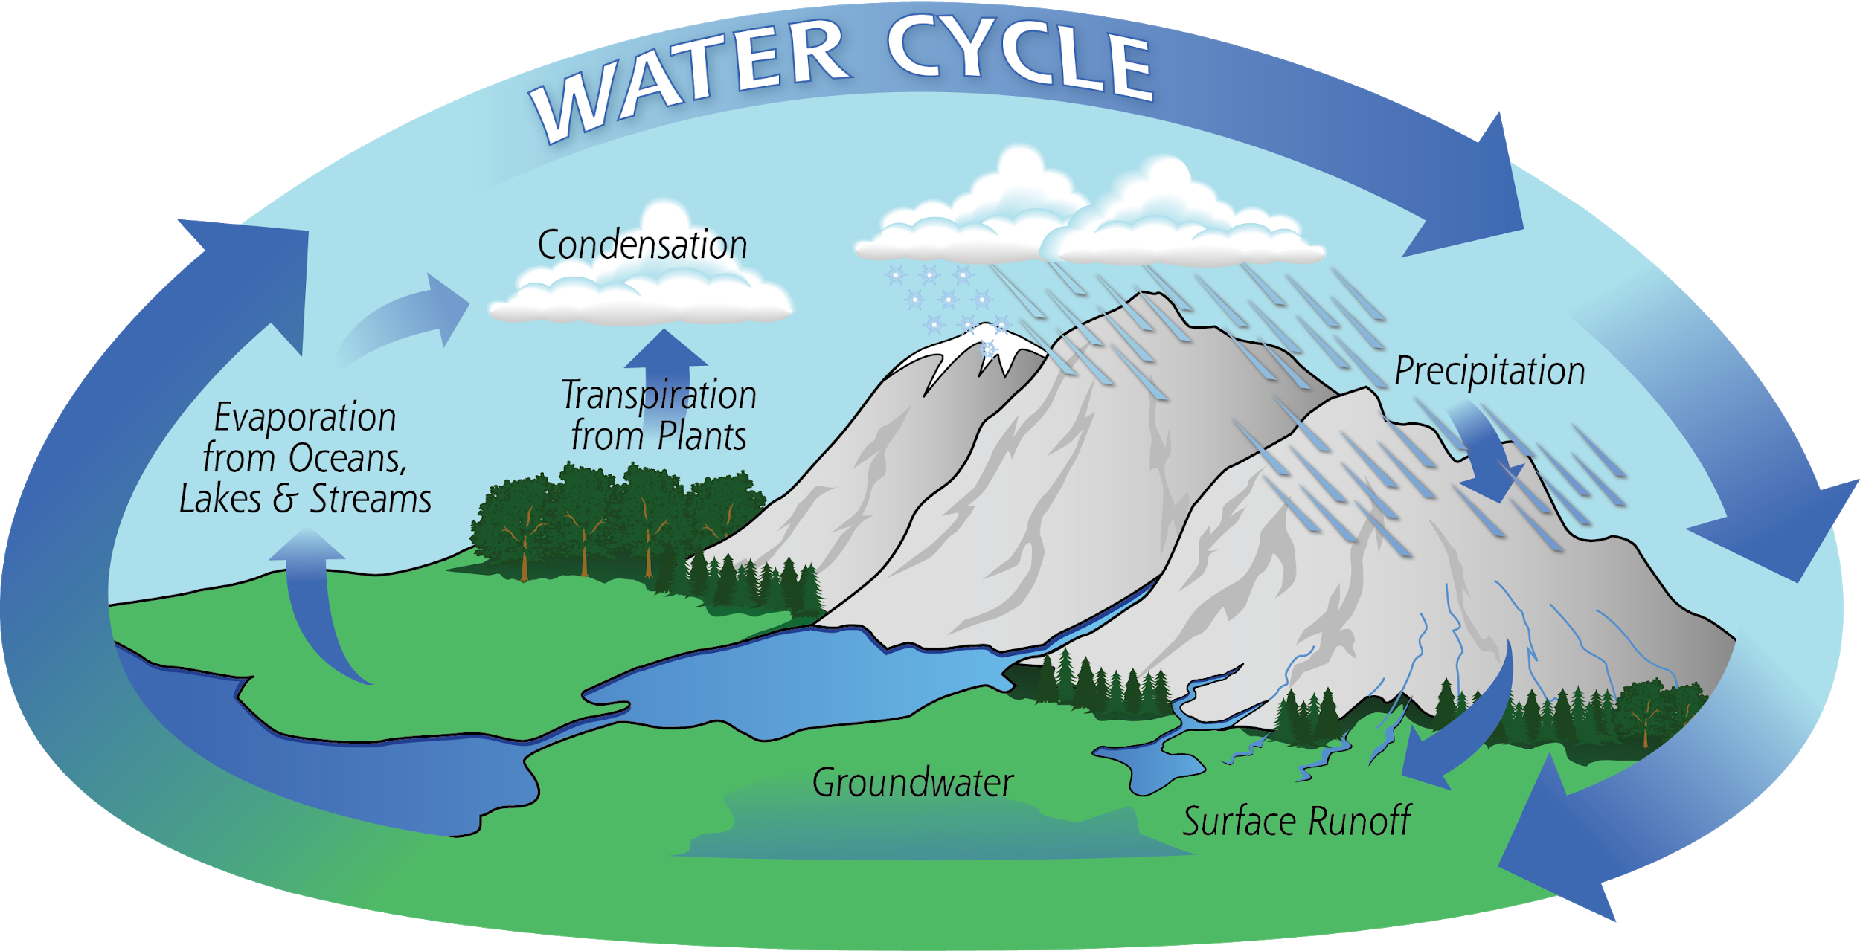 | Homai kia 5 ngā meka matua mō te wai  Give 5 facts about water  mō te water.  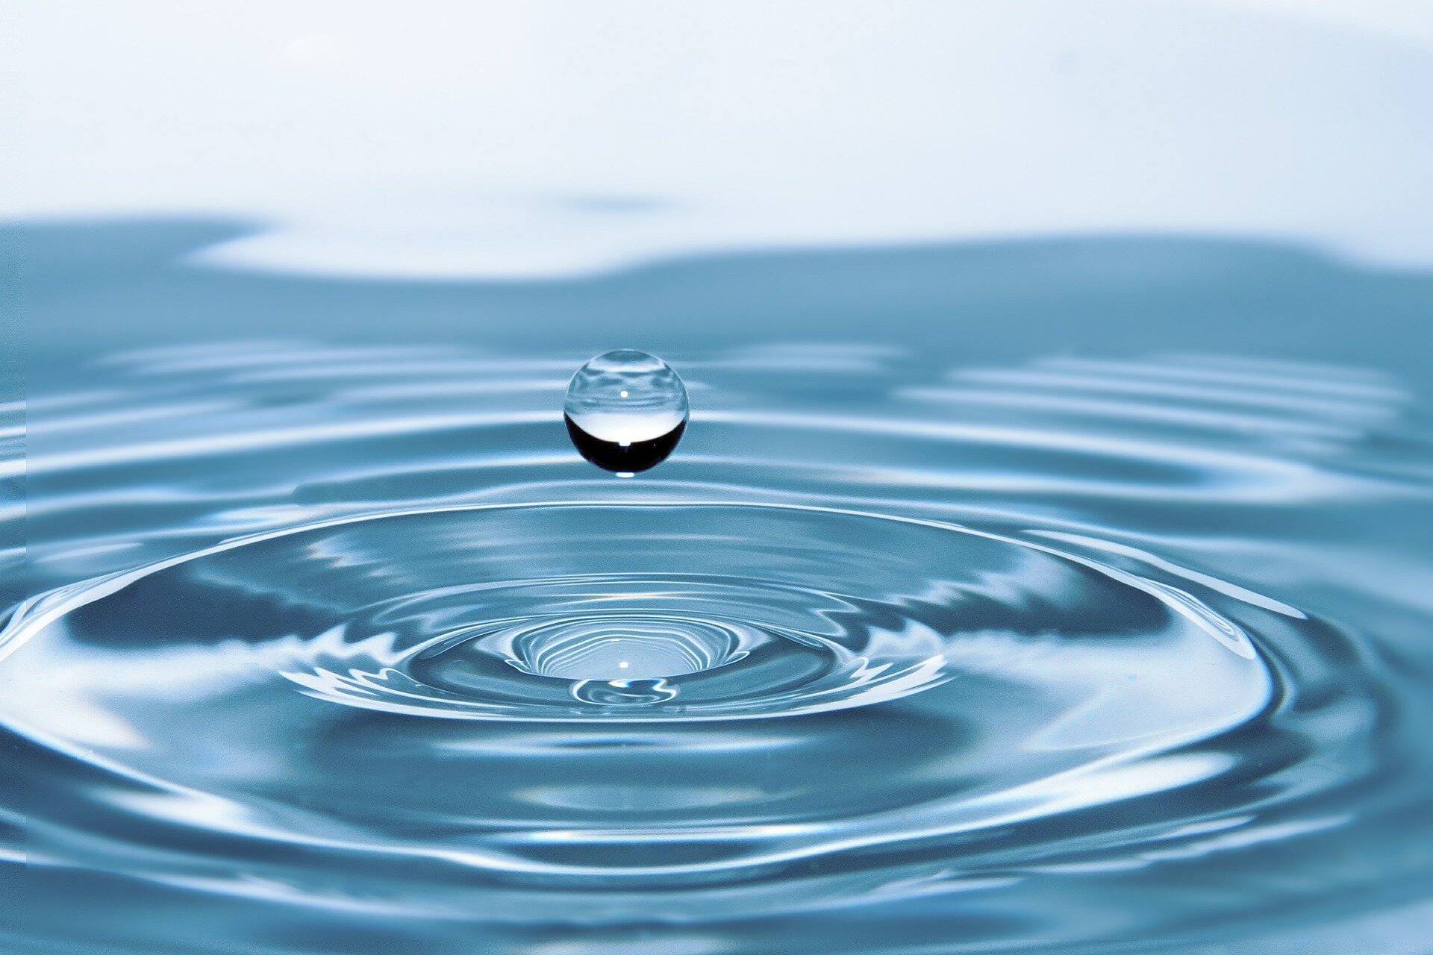 | Mātaki tētahi tūmahi whēako mā runga youtube a hāngai ana ki te wai.  whakamātauhia i taua tūmahi whēako.  Wiki tuawhitu ka tū koe ki mua i te akomanga ki te whakapuaki i tō tūmahi whēako.  Watch a science experiment about water  Test out the experiment.  Week 7 present your experiment to the class. 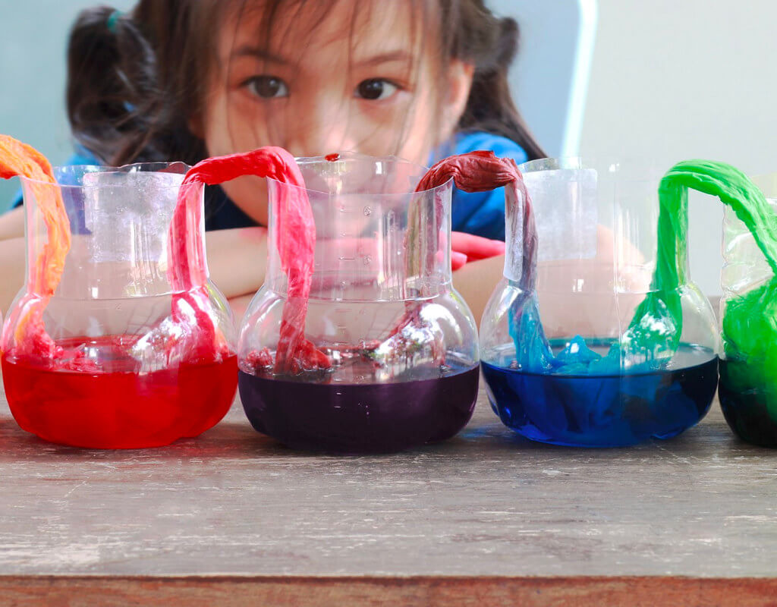
Hangaia tetahi hurihanga wai ahu 3
Design/Create your very own 3D water cycle explaining how it works. .
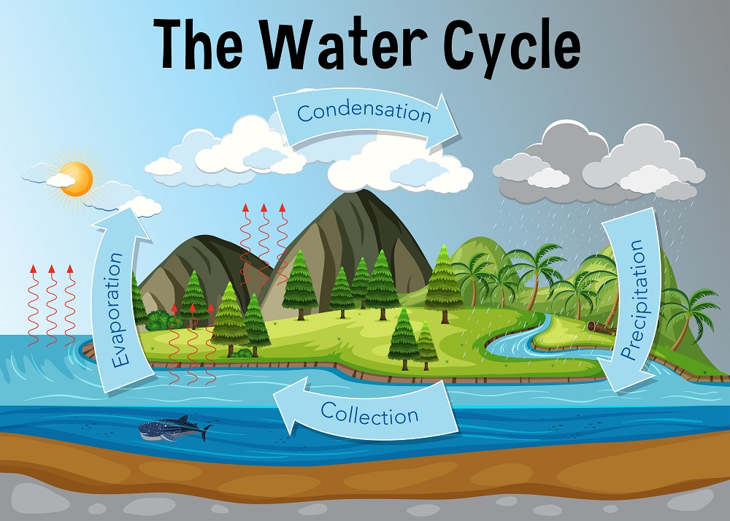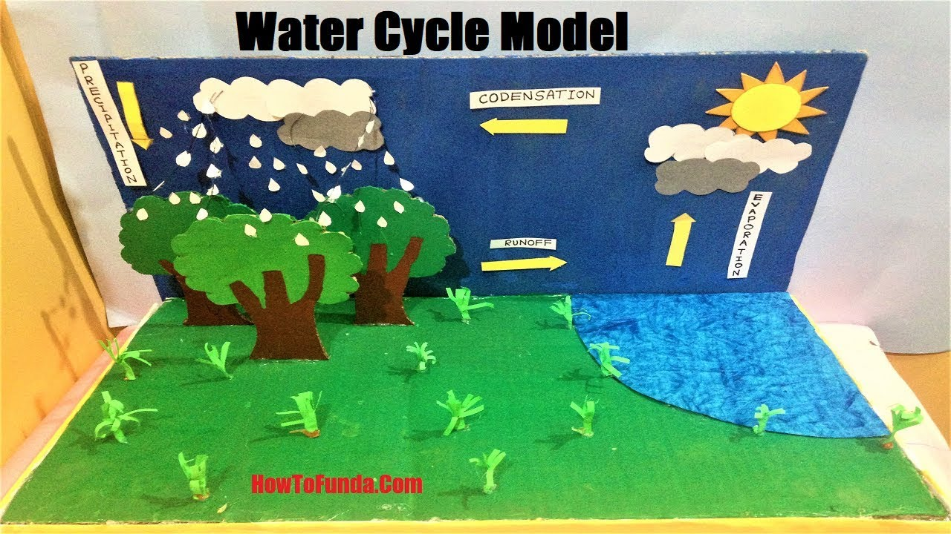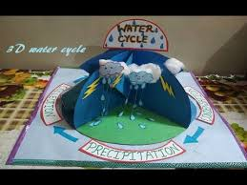

PAEARU/CRITERIA:
- Me awhina ia tāngata o tō whānau i a koe ki te hanga i tō ahu 3.
All whānau must contribute somehow in some way to your 3D.

- Kei a koe te tikanga mō ngā momo rauemi ka whakamahi.
It’s up to you what materials you would like to use.

- Patopato he kōrero/ whakamārama i ngaa waahanga.
Type/explain the parts of the water cycle.

4. Kia ātaahua kia pīrakorako mai ngā tae( Make it bright and colourful)

6. Kia kaha, kia maia, kia manawanui.
Have fun and think outside the box.

WHAKAHOKIA MAI/DUE: TBC Week 10

