General Knowledge Questions - ‘GKQS’
New Zealand y4-8
See if you can find out all the answers
- What is the name of the deepest lake in NZ?
- What is the Maori word for water?
- Where in NZ waters can you go out and see whales?
- What is the reason most people visit Rangitoto Island?
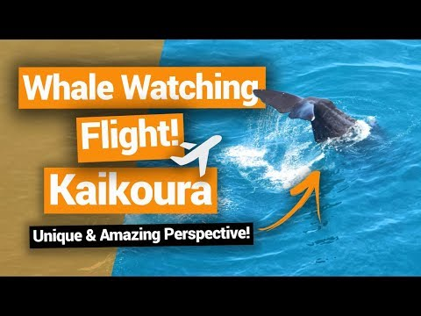
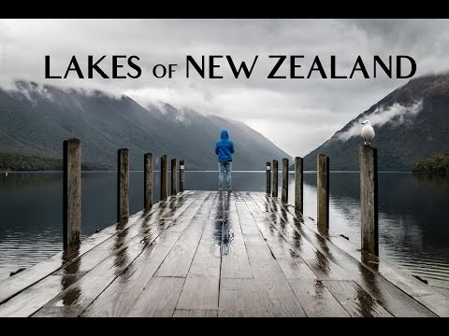

- Where was Peter Snell born and why is he famous?
- Name 3 NZ foods that are grown in market gardens.
- What is the name of the tallest tree in NZ?
- Name 3 native trees of New Zealand.
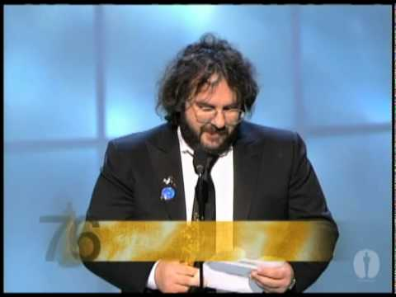
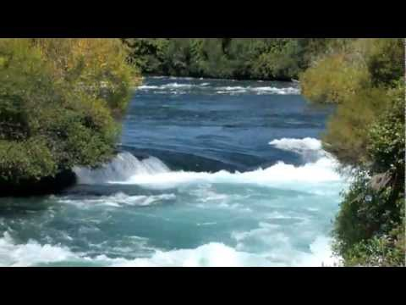
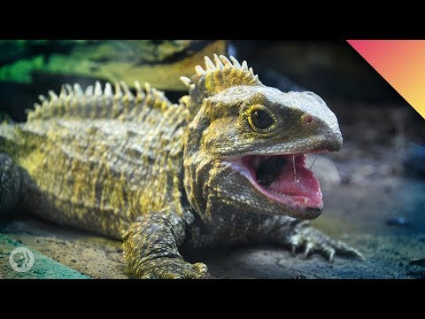

9. Where in NZ would you find a tuatara and what is it?
10. What is the Maori word for green?
11. Where does the Waikato River start and finish?
12. Name the New Zealand filmmaker who won an Oscar for “The Lord of the Rings”
